Muller's Method
Generalizes the secant method of root finding by using quadratic 3-point interpolation
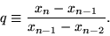 | (1)

Then define
 |  | 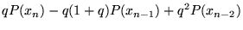 | (2)
 |  | 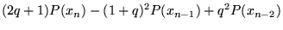
 |  |  | (3)
 |  |  | (4)
and the next iteration is
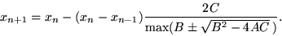 | (5)

This method can also be used to find complex zeros of analytic functions.

Muller's Method
Muller's method is best understood as another attempt to "model" the unknown function. At each step of the method, three points are used. Muller's method determines the quadratic polynomial that passes through these three points, and then solves for the roots of that polynomial, and chooses one of them to add as its latest point, while discarding the oldest point.
Muller's method can be fast, but there are several things that can go wrong. If the data points are very close, or lie on a straight line, there are accuracy problems in computing the coefficients of the quadratic, and more problems in determining its roots. Also, the coding for Muller's method is significantly more complicated than for other methods we've seen.

3. Regula Falsi
By now, you should be convinced that the Bisection Method actually works, (provided you start with an appropriate interval). You might, however, still have an uneasy feeling about our ``approximation'' of the root. We haven't really used any information about our function f in order the determine this ``approximation'', so we shouldn't be too surprised when it turns out to be a very bad one. Can't we do better? After all, we evaluate our function f in the two endpoints of our interval, but all we ever use of this information is the sign of the function in those points, so we are throwing away information. We are now going to adapt the Bisection Method in such a way that this extra information can be put to good use.
Imagine that we try to find the root of a first-degree function by using Bisection, that is, we try to solve , with , by using the Bisection Method. (If you don't have such a good imagination, you can scroll a little up and see it in reality.) So we get narrower and narrower intervals, leading to better and better approximations... But this doesn't make sense, because we could find the root immediately as soon as we have the function values in the two endpoints of our starting interval.
Of course, in the general case our function wouldn't be a straight line. But when you look on a sufficient small interval, most functions that are of practical importance behave more or less like a line. So what's stopping us from drawing a line through the endpoints of our interval, finding the place were this line intersects the x-axis and using this point as our approximation of the root of . Apparently, nothing. This modified version of the Bisection Method is often called Regula Falsi, which means "Wrong Line". We hope, of course, that the line is not too wrong.
It's time for some action again! Now see how Mr Jansen solves the same problem...
When you have tried Regula Falsi a few times on different functions, you will have noticed that, although the approximations of the root were quite good, they were almost always at the same side of the real root, so one point of the interval stayed the same all the time, and the interval as a whole shrunk only very slowly. This is a very common fenomenon with Regula Falsi, and one of the reasons that it is almost never applied in the way you just saw. I will explain the cause of this phenomenon in the next paragraph, but you can try to find it yourself first. A function that shows the phenomenon very good is 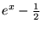. Try it!OK, here's the solution. When the interval gets smaller and smaller, you finally arrive at the point where the second derivative of has the same sign all over the interval. In that case, the function is either convex () or concave () on the interval. So any line you draw between two point on the graph of f will always lay entirely at one side of the graph, and therefore, all our approximations also lay at one side of the graph. The reason that shows this phenomenon so well is because this function is concave on the whole real axis; therefore, the approximations of Regula Falsi will always lay at the left of the real root.
Because of this phenomenon, Regula Falsi is almost never used "as is". However, it is quite often combined with other methods. It could, for example, be combined with the Bisection Method. Another popular combination is Regula Falsi together with the Secant Method. The Secant Method is at the time not discussed in this text; it is a modified version of Newton's Method, which comes next.

Method of False Position

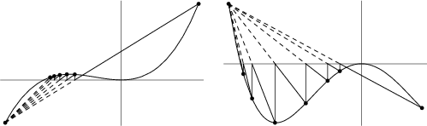
An algorithm for finding roots which retains that prior estimate for which the function value has opposite sign from the function value at the current best estimate of the root. In this way, the method of false position keeps the root bracketed (Press et al. 1992).
Using the two-point form of the line
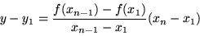

with y = 0, using , and solving for therefore gives the iteration
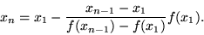

Brent's Method
Brent's method is a root-finding algorithm which combines root bracketing, interval bisection, and inverse quadratic interpolation. It is sometimes known as the van Wijngaarden-Deker-Brent method. Brent's method is implemented in Mathematica as the undocumented option Method->Brent in FindRoot[eqn, {x, x0, x1}].
Brent's method uses a Lagrange interpolating polynomial of degree 2. Brent (1973) claims that this method will always converge as long as the values of the function are computable within a given region containing a root. Given three points , , and , Brent's method fits x as a quadratic function of y, then uses the interpolation formula
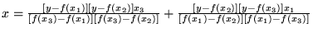
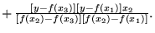 | (1)
Subsequent root estimates are obtained by setting y = 0, giving
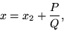 | (2)

where
(3)
(4)
with
 |  | 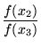 | (5)
 |  | 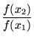 | (6)
 |  | 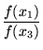 | (7)

