Phys. 337, Solid State Physics
HW #1
Due Friday, Jan. 21, 2005

1. Consider the following pattern in which the symbols represent different atoms:

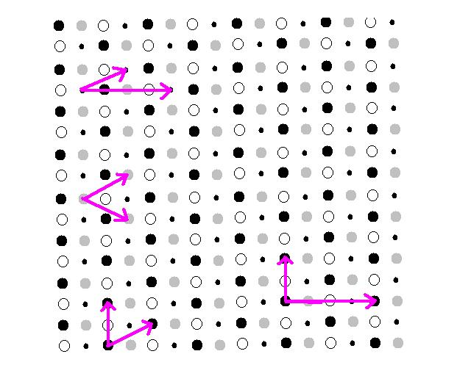
Indicate
(a) a possible set of primitive translation vectors

Primitive translation vectors always include one lattice point per cell and the primitive cell always has the minimum possible area/volume for a unit cell. There are actually an infinite set of primitive vectors, so there is no single “right” answer. As long as you pick 2 vectors that reach every lattice point (and no more) and fill all space with the unit cell, you are correct.
The three sets of vectors on the left side of the lattice above are each correct. (You should convince yourself that all three work.)

(b) the basis associated with each lattice point

This is the repeating unit, meaning the different atoms that repeat in order to create the actual lattice of atoms. For instance, the following set of atoms could be the basis using the primitive cell on the lower left. All primitive cells in this picture will have the same number of each type of atom (one of each in this case). The basis is chosen such that it corresponds to the primitive unit cell (i.e. once you pick translation vectors and draw a cell, that selects your basis).

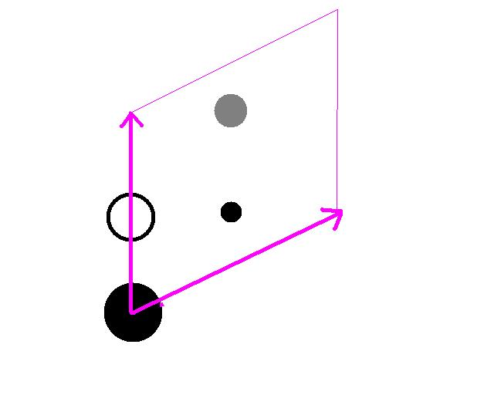

(c) a rectangular conventional unit cell (repeatable on a rectangular network)

The vectors on the right hand side of the picture above is a possible conventional cell, which includes 2 lattice points, 2 primitive cells, and has twice the area of a primitive cell. Calculating Miller indices will be much simpler on this cell though! It also better reflects some of the crystal symmetries (like left-right mirror symmetry) that an oblique lattice doesn’t typically possess.

(d) Express the location of each atom in the basis according to multiples of the primitive translation vectors from part (a) (i.e. give r_{j} = x_{j} $\vec{a}$ + y_{j} $\vec{b}$ for each atom j in the basis where x_{j} and y_{j} are between 0 and 1)

For this answer, the main goal is to understand how the basis is indicated using the translation vectors. Specifically, that each atom is specified relative to the lattice point associated with the basis in terms of the translation vectors. If we a re using primitive vectors as in this case, this is a non-orthogonal coordinate system. The basis is chosen by identifying atoms within the unit cell such that x_{j} and y_{j} are between 0 and 1. For instance, using the primitive vectors on the lower left as in part (b):
black circle = (0,0)
white circle = (0, 0.5)
little black circle = (0.5, 0.25)
grey circle = (0.5, 0.75)

Another, less obvious solution is using the middle primitive cell on the left of the diagram. In that case, the basis would be:

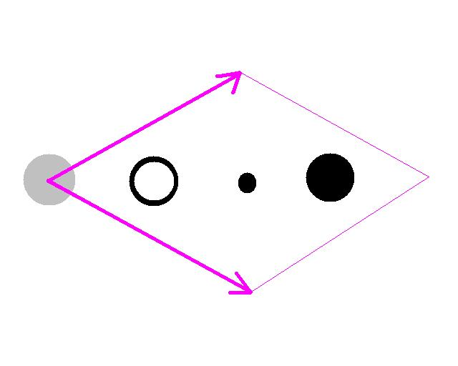

grey circle = (0,0)
white circle = (0.25, 0.25)
little black circle = (0.5, 0.5)
black circle = (0.75, 0.75)

2. (a) In 2D, solid disks of diameter D can pack most densely in a hexagonal lattice. What is the packing fraction of the disks (area covered by disks divided by total area)?

The easiest thing is to find a simple geometrical shape (perhaps a unit cell) and figure out how many particles are in it. For instance:
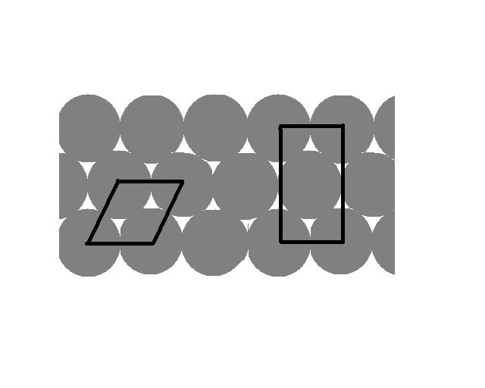
On the left is a unit cell with one disk in it (area π(D/2)²). The area of the cell (area of a tilty-square) is A = |a₁ × a₂| = a₁ a₂ sinθ = D·D·sin(60˚) = $\frac{\sqrt{3}}{2}D^{2}$. The packing fraction is then the area of the disk over the area of the parallelogram, or 0.907.
You could similarly use the rectangle on the right, which has 2 disks in a D by 3^{1/2} D rectangle.

(b) The packing fraction of an fcc lattice (e.g. the lattice copper forms) in 3D is 0.7405. The nearest neighbor distance for copper is 2.56 angstroms and a typical atom has a mass of 63 amu. What is the density of copper?
The nearest neighbor distance, if we imagine these things as spheres, is just the sum of the radii of neighbors, which is the diameter. D = 2.56 Å. Also, we need 1 amu = 1.66 × 10⁻²⁴g (or for copper, 63g = 1 mole = 6.02 × 10²³ molecules). A couple ways of doing it:

There is one atom in a volume of (4π(D/2)³/3)/0.74 Å³ = 11.871 Å³ which has a mass of 63 amu = 1.046 × 10⁻²² g. The density is ρ = 8.811× 10⁻²⁴ g/ Å³ = 8.811 g/cm³.

3. Imagine a Cartesian coordinate system indexed by integers n_{x}, n_{y}, and n_{z}.
(a) If there is a lattice point wherever all the indices are odd, what lattice is formed?

This is simple cubic (e.g. draw out the z = 1 plane which is a square lattice, z = 2 is empty, z = 3 is the same as z = 1,…)
.
(b) If there is a lattice point wherever the sum of the indices is even (n_{x} + n_{y} + n_{z} = even), what lattice is formed?

fcc. Again, probably easiest to draw out the z = 0 plane (a centered-rectangular lattice which you might convince yourself is a plane of fcc cell faces).

4. A crystal has primitive translation vectors (in Angstroms, Å) a₁ = 3i, a₂ = 3j, a₃ = 1.5(i + j + k).
(a) What is the volume of the primitive cell?

V = a₃ · (a₁ × a₂). [Note that we could have named this vectors differently, so I chose to use the simplest vectors to do the cross product.] V = 1.5(i + j + k)·(9 k) = 13.5 cubic Angstroms.

(b) What are the Miller indices of the plane most densely populated with atoms (i.e. closest interatomic spacing or nearest neighbor distance)?
The shortest nearest neighbor distance is between the central atom at (0.5, 0.5, 0.5)a and any of the corners. This is a (110) plane (see Figure 1.14, which gives an example of the (110) plane).

5. Why is it only possible to have lattices with rotational symmetries of 0, 60, 90, 120, and 180 degrees? Why not 45 degrees for instance? (or 72˚ like Dr. Hughes’s quasicrystal?) Starting with a lattice with two primitive lattice vectors of length a separated by some angle φ that we assume is also a rotational symmetry:
a₂

φ
a₁

All of the points of the lattice are reachable by combinations of these vectors. Now rotating clockwise by the assumed rotational symmetry:

a₂’ = a₁

a₁’ = a₃

a₂ rotates to become a₁ and a₁ rotates to become a new vector, a₃. For this to be a true rotational symmetry, we have to be able to reach all the same lattice points still. Using combinations of a₁ and a₃, what is required in order to reach the lattice point that was originally at the end of a₂ (the dot)? [There is a constraint on φ that must be met.] What rotational symmetry angles are allowed based on your answer?

First, it’s worth noting that if a₂ rotates and still reaches all the same points on the x-axis that a₁ did, these two translation vectors must have the same length a.
If φ < 90, we will have to use –a₃ and one or two a₁ vectors. So –a₃ + n a₁ = a₂ is required. Schematically:

And the requirement boils down to the fact that the length of the dashed vector (which is necessarily two times the length of the horizontal component of a₃ or a₂) must be an integer number times the length of vector a₁ = a. That is:
2 a cos(φ) = n a
If you look at the case where φ is between 90 and 180 degrees, you might convince yourself that the general rule is:
|2 a cos(φ) | = n a

|cos(φ) | = n /2

Since cosine is less than or equal to one, cos(φ) = 0, ± 0.5, or ± 1. These angles are 0, 60, 90, 120, and 180 degrees.

