Phys. 337, Solid State Physics
HW #2
Due Fri., Jan. 26

1. (rewording Kittel 1.2) Consider planes in an fcc lattice with Miller indices (100) and (001). These Miller indices are in relation to the conventional cell translation vectors a = a i, b = a j, and c = a k (these “conventional” vectors are used precisely for these kinds of reasons – that referring to planes relative to a cube is more straightforward than using non-orthogonal vectors).

However, since Miller indices are based on some set of translation vectors, we can give Miller indices based on the primitive translation vectors. Using the primitive translation vectors for an fcc lattice a = 0.5 a (i + j), b = 0.5 a (j + k), and c = 0.5 a (i + k), write Miller indices for the two planes specified above (in other words, write the Miller indices based on primitive lattice vectors that still identify the same planes of atoms).

2. (Ellliot 2.5) Derive an expression for the bulk modulus of an fcc Lennard-Jones solid at the equilibrium atomic distance.

3. (Version of Kittel #3.2)
(a) Using the Lennard-Jones potential, calculate the ratio of the cohesive energies of neon in the bcc and fcc structures (Answer: 0.958). The lattice sums for the bcc structure are ∑p_{ij}⁻¹² = 9.11418 and ∑p_{ij}⁻⁶ = 12.2533.
(b) Using the answer from part a, which lattice does neon form and why?

4. In the following fictitious 2D ionic crystal, the black circles represent positive charges and the white circles represent negative charges (± e). The nearest neighbor distance is R₀.

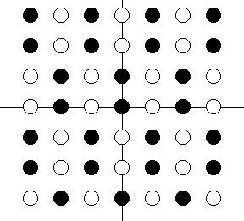

Use the positive charge at the origin as the reference atom. It has 4 nearest neighbors (n), 4 next-nearest neighbors (nn), 4 next-next-nearest neighbors (nnn), and 8 next-next-next nearest neighbors (nnnn). The Madelung constant is a sum over all possible atoms. However, what would the sum be after including terms up through the
(a) …nearest neighbors (n)
…next (nn) [i.e. including both the nearest neighbors and the next nearest]
…next-next (nnn)
…next-next-next (nnnn)
(b) Do you think this would be a stable crystal? Explain. Would your answer be affected if the charge at each site was ± 2e?
(c) Assume the equilibrium lattice spacing is 2 Angstroms, and the repulsive core has a characteristic length of ρ = 0.2 Angstroms. What is the average cohesive energy per atom? What is the energy of two oppositely charged atoms separated by 2 Angstroms relative to the atoms being separated by an infinite distance?

