Phys. 337, Solid State Physics
HW #4
Due Fri., Feb. 9

1. The following is an electron density plot in 1D.
(a) What is the lattice spacing a?
(b) Draw the 1D reciprocal lattice for this crystal.
(c) Write the Fourier series that describes this function (either the series involving S_{p} and C_{p} or the one with n_{p})? [Basically, I’m asking you to do a Fourier transform by eye, but there are just a few non-zero terms, so trial and error plus a plotting program should get you there.]

2. (Revision of Kittel #2.7) Consider a line of atoms ABABAB….AB with an A—B bond length of a/2. The form factors are f_{A} and f_{B} respectively. The incident beam of x-rays is perpendicular to the line of atoms and scatters as it travels through the crystal.
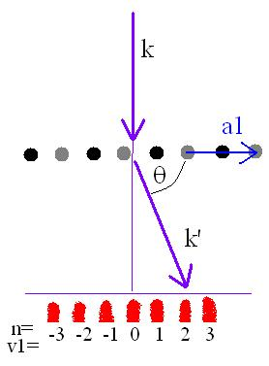
(a) Show that the interference condition is nλ = a cosθ, where θ is the angle between the diffracted beam and the line of atoms. This is based on the picture that light comes in and atoms scatter/re-emit the light coherently in all directions.
(b) Show that the intensity of the diffracted beam is proportional to | f_{A} - f_{B}|² if n is odd and | f_{A} + f_{B}|² if n is even.
(c) Make the simplifying assumption that the atomic form factor is simply equal to the number of electrons in the atom. Sketch a rough plot of intensity versus distance (e.g. if you put a screen up to observe the diffracted light) if A and B compose the following crystals.
⎯ Potassium bromide: A = potassium, B = bromine
⎯ Potassium: A = B = potassium [qualitatively, why do you get the result that you get?]

