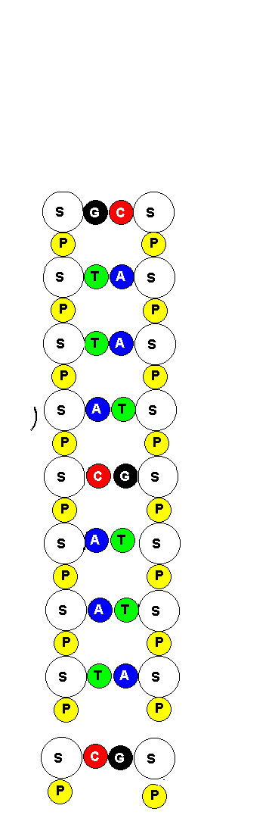
Key

S = Sugar

P = Phosphate

A = Adenine

G = Guanine

C = Cytosine

T = Thymine

H = Hydrogen bond

