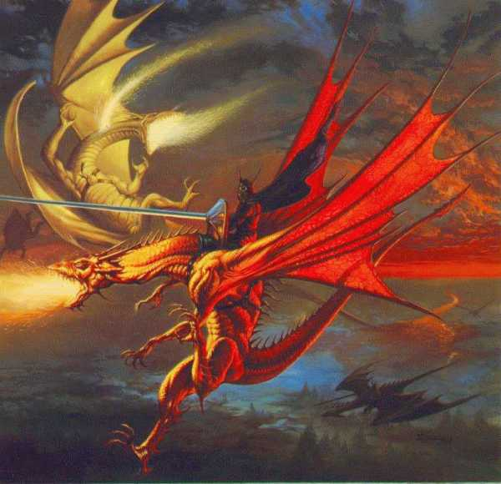

From The clutching shires,
Out of the mires of despair,
Rode the knights of good,
Sickened by this awful sight,
The misery and suffering,
The wails of children,
The cries of mothers weeping,
Rose in a cacophony of noise,
Around the warriors.

One man,
Barely able to keep from hurling his provisions,
To the poor, wretched peasants,
Felt like all of Ansalon was,
To put it simply,
Already in the grip of the dark queen.

Banishing that thought from mind,
He rode on under a bleak gray sky,
Into the clutches of the vile goblins.

Huma sallied forth and struck,
When discovery was impending.
Cutting a swath among the evil,
Mottled mass of cutthroats,
Fighting his way as his comrades,
Charged the shocked creatures,
Killing, maiming,
Until the ground was slick with their blood,

As was it seemed with victory there was,
Always a price to pay,
Out of the dark and desolate forest
A freakish, pale visage appeared,
An apparition of a wolf,
Snarling, and baring its many rows of teeth

The panicked horse galloped headlong
Into the brush and fell,
Many long feet, into a gully.
The contingent of Knights rode on,
Thinking they had lost,
Their brave and spirited companion.

