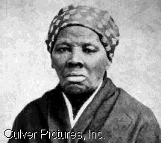

By: Alex Beck
Harriet Tubman, born a slave in Dorchester County, Maryland, made 19 journeys on the Underground Railroad to Canada. She freed approximately 300 slaves. She was an associate of Frederick Douglass, John Brown, William H. Seward, and other important abolitionists. She became known as the Moses of her people.
Since the Fugitive Slave Law was passed not nearly as many people have their companions escape to the north. But there still a lot of people willing to help. She does not let anyone desert or go back once they are on the Underground Railroad. If they even attempt to do any of these things she will put a pistol up to their heads and say something that will scare them into proceeding with North
Now during this time of war she has volunteered to fight as a cook, a nurse, a spy, or a scout.

