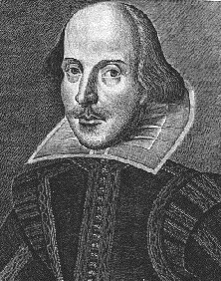

William Shakespeare

Rome & Juliet Final Project

By: Justin Beck
In the Year of Our Lord
April 23, 1998
2nd Period English

