http://satie.arts.usf.edu/~ooguibe/africa7b.htm
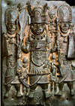

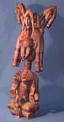
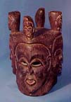

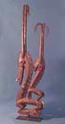
http://www.introspecinc.com/warehouse/rpg0454.htm

http://www.lib.virginia.edu/dic/exhib/93.ray.aa/African.html
