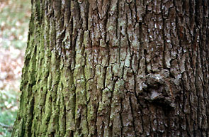

Dashefsky, Steven H. Microbiology: High School Science Fair Experiments, New York: McGraw-Hill, 1995.

Collier’s Encyclopedia. Canada: Crowell & Collier Educational Corporation, 1970.

Encyclopedia America. New York: American Corporation, 1966.

Rosita Arvigo and Michael Balick. Rainforest Remedies: One Hundred Healing Herbs of Belize, Twin Lakes, Wisconsin: Lotus Press, 1993.

Margery and Howard Facklam. Healing Drugs: The History of Pharmacology. Oxford:
Facts On File, 1992.

Castleman, Michael. The Healing Herbs, Emmaus, Pennsylvania: Rodale Press, 1991.

Chevallier, Andrew. The Encyclopedia of Medical Plants, New York: DK Publishing, 1996.

Asa, Rick. “Common tree bark yields potential skin cancer cure (Online) Available http//:www.uic.edu/depts/paff/uicnews/archive/uicnews/uicnews9503/uicnews9503-22/50524025.html.

Coombes, Allen J. Trees: The visual guide to more than 500 species of trees from around the world, New York: Dorling Kindersley, Inc. 1992.

Collingwood, G.H and Brush, Warren D. Knowing your Trees, Washington, D.C: The American Forestery Association, 1937.

