The Chapter 5 quiz covered how ions become stable through achieving noble gas configuration. The proper method for writing out the names of ions long hand was also included. One must also translate the long hand form into chemical equations.

♣Alkaline and alkaline earth metals must donate electrons to achieve a stable or full octet, i.e. noble gas configuration.
♣Groups 13 through 17 must accept ions to become stable.
♣This process does not involve transition metals and involves only the exchange of electrons.
♣The long hand notation of ions differs from group to group and number of electrons.
♣It is necessary to be familiar with the symbol of the chemical element and its long hand notation to change from one to the other.

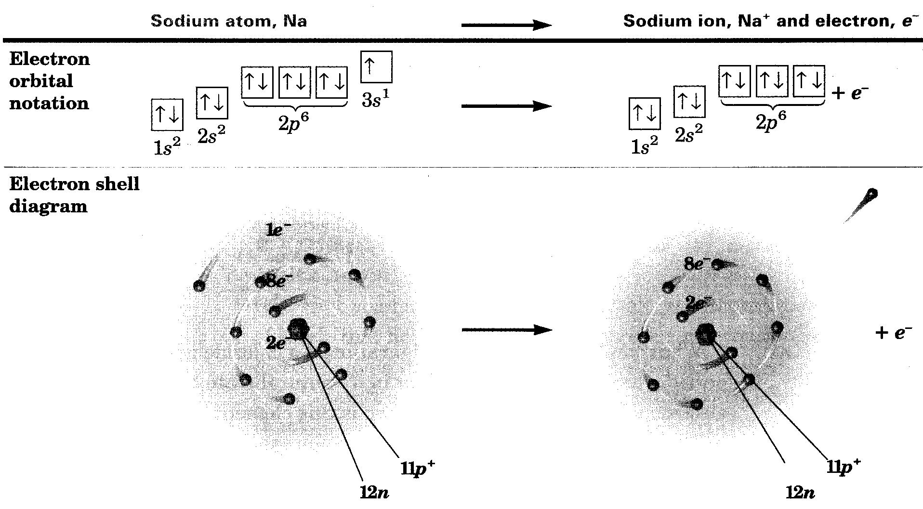

Ex. KCl - Potassium Chloride
Ex. Magnesium, Mg, donating 2 + to become stable
Ex. Chromium, Cr 3+, Chromium (III) ion

I understand how to properly organize and name different ions and atoms, through use of the periodic table of elements. I learned how the noble gases are stable because all of their energy levels are full, in an octet.

