Leonardo Da Vinci
Adoration of the Magi, Florence. 119KB
http://sunsite.unc.edu/cjackson/vinci/
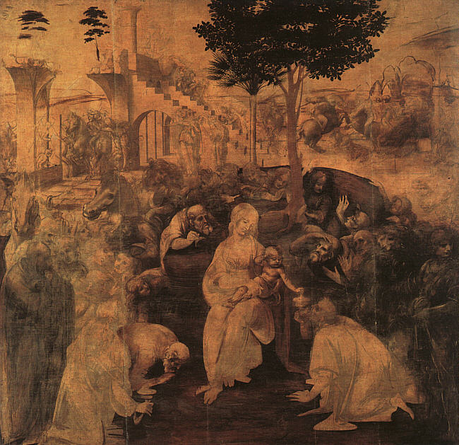

MICHELANGELO
An eye-level photo of the inside of the chapel from floor to ceiling.
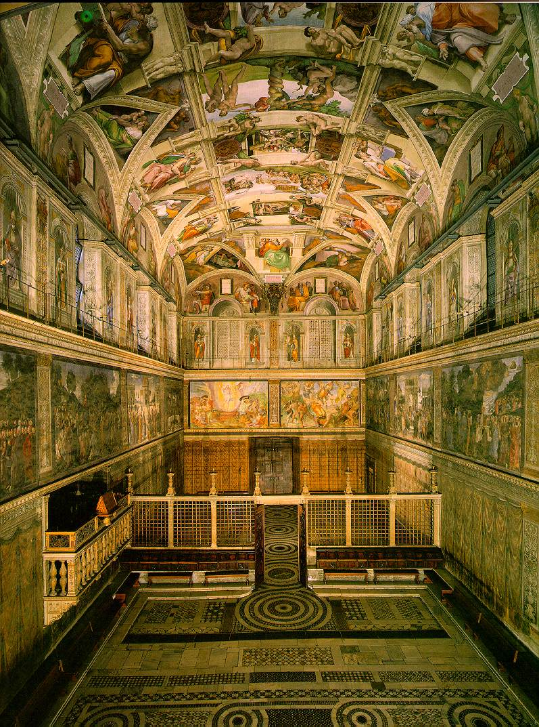
http://lonestar.texas.net/~mharden/artchive/ftptoc/michelangelo_ext.html
DONATELLO
Habbakuk ('Lo Zuccone')
http://lonestar.texas.net/~mharden/artchive/ftptoc/michelangelo_ext.html

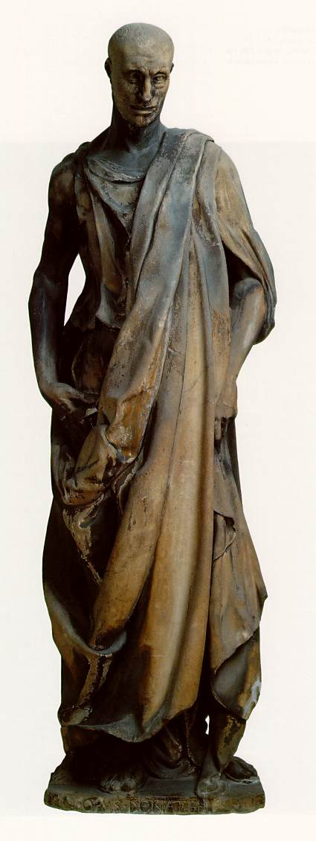

Raphael
St. George Fighting the Dragon (Washington)
http://lonestar.texas.net/~mharden/artchive/ftptoc/michelangelo_ext.html
