As the sun set behind the mountains in the painted mesa,
An Indian lay dying, shot by a bullet of death,
Slain by the greedy cowboy.
He was sprawled lifeless on the desolate, dusty flat lands,
As the white man walked away from his bloody corpse.
The Indian was shot straight through the heart by the weapon that could kill so many.
He was brutally murdered for the pleasure of the evil cowboy.
As the sun set further the bloodstain grew larger over the plain of dust surrounded by a huge plateau.
Soon the Indian family will mourn for the horrible loss of a human life.
As the earth turns from day to night the family will find their beloved son dead and lifeless.

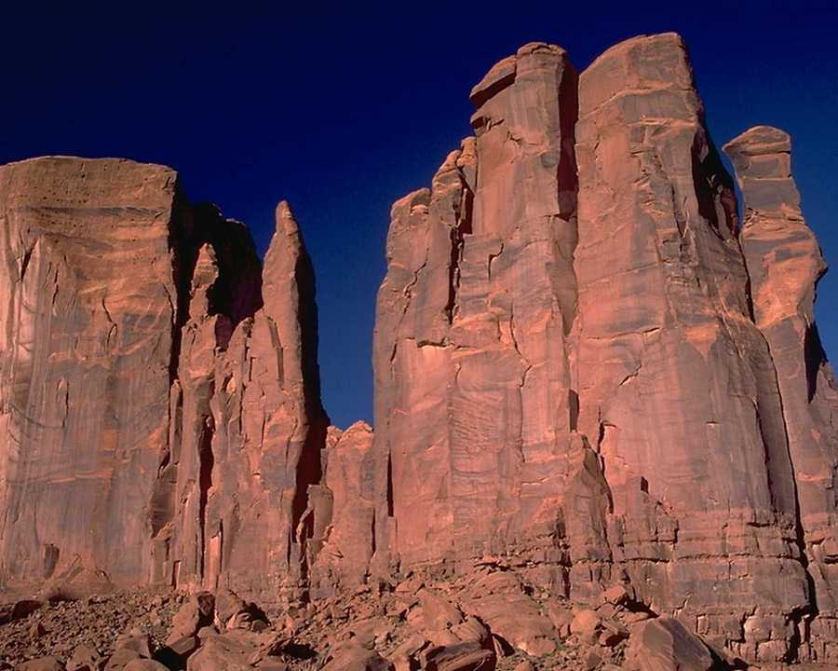

Railroaders made the USA a much smaller place

Many men worked all day for very little pay

They always moved on once the track was done

Every day they worked on a track a thousand miles long
Railroaders made the USA a much smaller place

I work in the fields all day.
I make my own food.
I wake up early in the morning no matter what day of the week.
My favorite season is winter because that’s when I have less work.
The weather is always important,
To me and my fields
No matter how I try sometimes,
The weather can make me or break me.
Can you guess who I am?

Miners

In the mines deep in the Earth

Night is what they see all day
Eventually they will find their way
Raise their picks
Strike the earth

In winter I drop off hay in the snowy Fields.
In winter the cattle are cold and covered with snow.

In spring I help the pregnant cows and start on the long drive. AS spring arrives, I am reminded of the aroma of pollen and flowers, awakened from their winter slumber. Yet, with that smell, I am reminded also of what a true farm smells like,
And it’s not pleasant.

In Summer I continue the long drive in the simmering summer heat.
A quick dip in the water hole and I feel human again.

In fall I bring in the bulls for mating season.
In fall I prepare hay for the winter.

