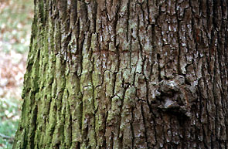

I started this experiment by finding and identifying four trees in my yard. Next, I cut chunks of bark from each tree. I sanded the necessary bark off and put ¼ teaspoon of bark in four separate 40-mL beakers, that were labeled accordingly. Then, using a graduated cylinder, I measured 7 ml of distilled water and added it to each of the four beakers. I then sealed the top off with aluminum foil and put the beakers in the oven to sterilize for 30 minutes at 350 ° F.

While the beakers were sterilizing, I made the sterile disks. With filter paper that I acquired from a hospital, I punched out 150 small disks. Then, I filled a 250- ml beaker with 100-ml of distilled water and added the discs to it. I placed this in the oven to sterilize for 30 minutes at 350 ° F.

After I had sterilized both of the materials, I added the discs to the bark solution. Thirty five discs per beaker, respectively. However the tweezers I used had to be sterilized before use and in between each beaker, so as to prevent contamination. Next, I had to again sterilize the beakers. After the beakers cooled, I sealed the tops with the parafilm and looped a rubber band around the lip of each beaker.

I transported the beakers to a hospital laboratory to place the discs on the blood agar plates with the bacteria. The lab had prepared pure colonies of the two bacteria (E coli and B. subtilis). I streaked each of the 24 blood agar plates with the bacteria, using a different sterile loop for each. They were labeled with the kind of bark, the time in the incubator (24, 48, and 72 hours) and the type of bacteria used (E. coli or B. subtilis). I then, using disposable, sterile tweezers, placed four bark soaked discs on each plate, one centered on each streak. Next I placed the plates in an incubator at 37 degrees C, or body temperature. I examined the plates 24, 48 and 72 hours after preparation and measured the zones of inhibition around the bark soaked discs.

