Licensing Free World Alliance Bar
For All Around Generally Ideal Alloy And All Kinds Of Ideal Specific Alloy; Die Casting Production, And General Matter Storage/Decoration Bars To Be Printed On, And For Metal Variants Acrylicly Decorated Designs And/Or Pictures, And Uniformly Acrylicly Plated In Gold All The Way To Colored Gemmed Bars And Anything At All Of The Design.

For Initial Manufacturing By: Asny Craft Factory
AvAlne - Free World Alliance Bar©.sfx 8"x5"x0.5"
2.448 KG [Steel] 18-8 stainless 46.8 micrometers Thick Acrylic Plating
+ 1/4 mm Give Between Contact Lock Sites;
1/8 mm Taken From Both Sides Of Contact Sites On Top Of Plating
Winni lu
sale08@asnypin.com
86 15015149250

For Initial Wholesale By: AC ANSEN CRAFTS Official Store
AvAlne Free World Alliance Nazi Gold 2.448 Kilo Bar
AC ANSEN CRAFTS Official Store
$188.14_30% Off
$267.42
Mike Chang

FWA Matter Bar:
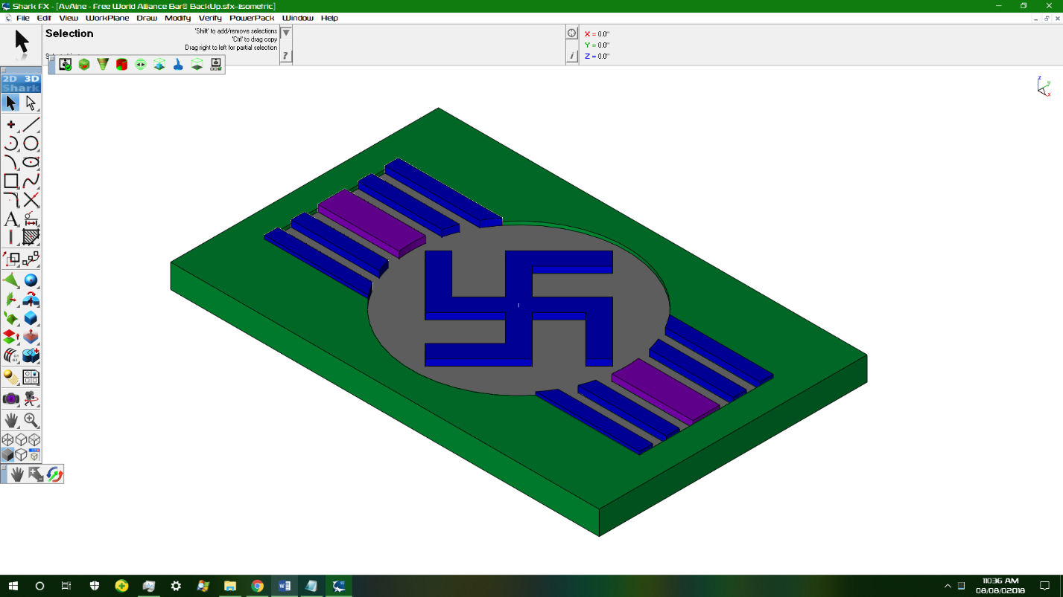
AvAlne - Free World Alliance Bar©.sfx {File}

The FWA Matter Bar Epitomizes Ideal Form, Abstract Beauty, And Perfectly Efficient Spaced Lock Stacking Due To The Design’s Negative On The Other Side. For The World’s Gold To Be Stacked Such That A Deviant Cannot Easily Knock Over A Properly Locked Stacked Stack Of FWA Bars(Unless The Whole Stack Topples Over) And For It To Be Pluckable By The Properly Designed Finger Pluck Space When Locked, A Design Such As The Free World Alliance Bar Or A Pentagram Equivalent Such As A Witch Friendly Equivalent;
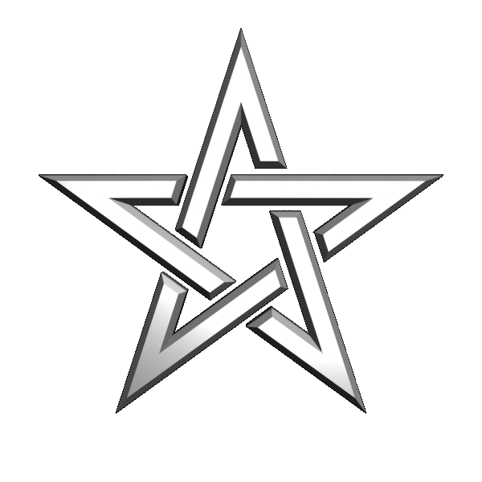
, Is The Ideal Solution To Look Both Magical And Bannered. The Banner Look Gives The FWA Matter Bar Both Easy Locking Joints To Fit The Lock Stacking Capability And A Regal Persona Signaling Good Feng Shui Political Power To The Central Circle Where Anyone Can Place An Iconic Symbol Or Shape Which Will Lock Stack With The Negative On The Other Side Just As Long As The Design Measurements Before A Specifically Timed Acrylic Bonding Process Done With The Desired Color(s) Allow Just A Tiny Bit Of Leeway For The Reverse Sided Negative to Slide Into The Positive.

I, AllA Erawa Viacad, Legally Known As Alexander Gerhard Beck, Would Like To Develop Idealized Product Design Measurement Specifications For This Lock Stack Process And Other Things About The FWA Matter Bar Before The Mold Is Made For The Product That I Would Want To Contract For Licensing Internationally. I Would Also Like To Contract Out Other Designs I Have Developed Like The E-Democracy Symbol: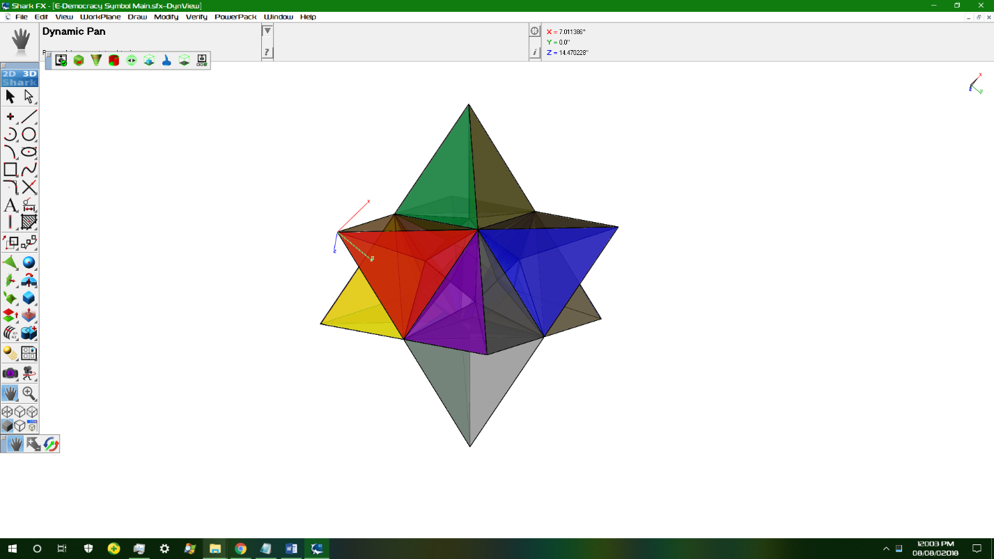
Please Contact Me Back If www.AliExpress.com Or www.Alibaba.com Or A Store/Manufacturer/Lab Will Let Me Test The Idealizations Of These Products In Your Laboratories In China, I Don’t Have A Job Right Now{And Am On SSI For An Erratic Sleep Schedule} So I Can’t Pay For The Trip, But I Would Be Eager To Help China Design Other Icons Into The Bannered Bar Template And Acrylic Or Matte Print Picture Designs Like This One;
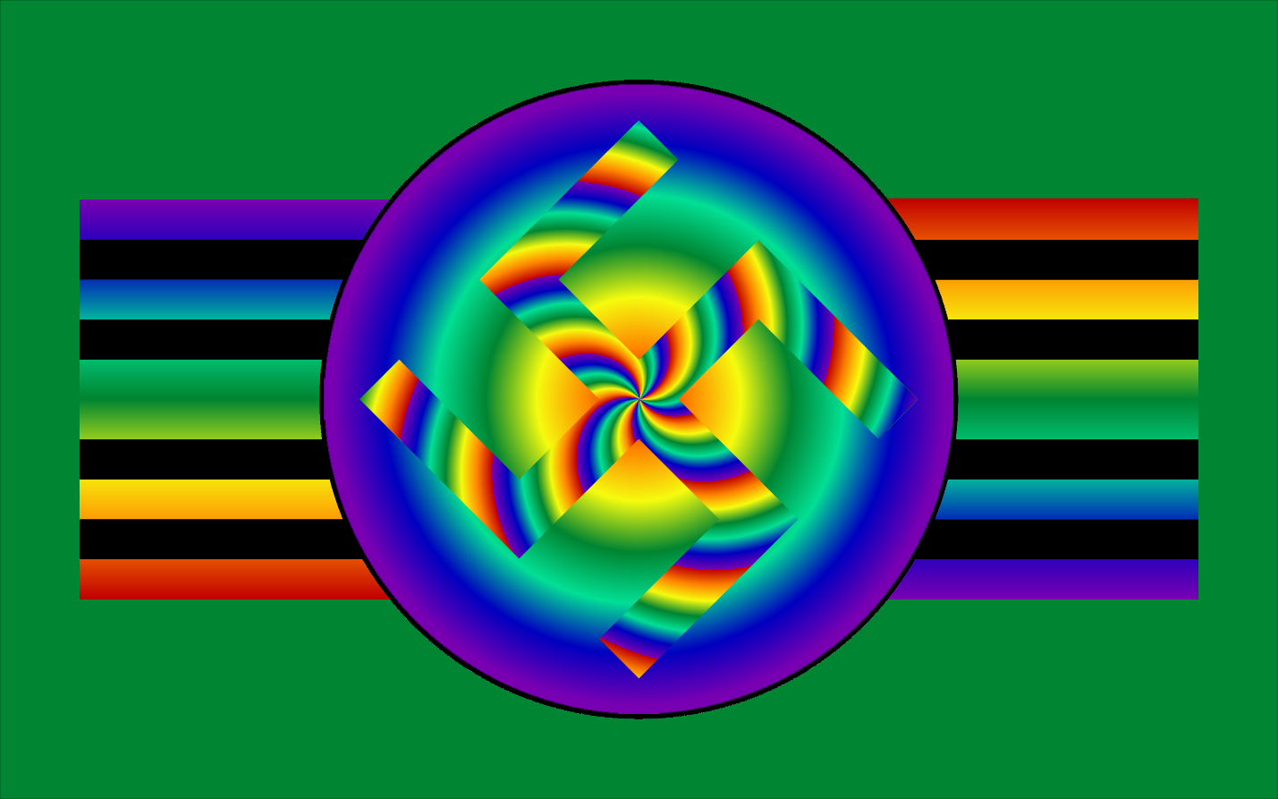
For Licensed Sale Internationally, And I Will Provide You The CAD Files And Relevant Java FX Source Codes If And When I Get To China For Me To Manage The Idealization Process.

-Dr. AllA Erawa Viacad, Private Owner Of The www.nanofirm.org WebRing

